Joint TA1/TA2 Call Minutes

June 5th, 2025; 11:00 – 11:55

Present:

Regrets:

Next meeting: June 12th, 2025; 11:00 – 11:55

Zoom: https://uni-ms.zoom-x.de/j/67022118320?pwd=cE6Q1Jd0R5c6D8ha608NBK06j13y0F.1

Meeting-ID: 670 2211 8320; Password: nfdi4imu; host code: 584003

Emergency URL: https://conf.dfn.de/webapp/#/?conference=979176819, PIN: 7570 (host pin: 7579)

# Organisational

 [Use cases and user stories](https://drive.google.com/drive/folders/1BN0XFlBmmLfuQX2CDGKhz5XsKK7YnSbS)

 [Miro board – Data model](https://miro.com/app/board/uXjVK29Q7KU=/)

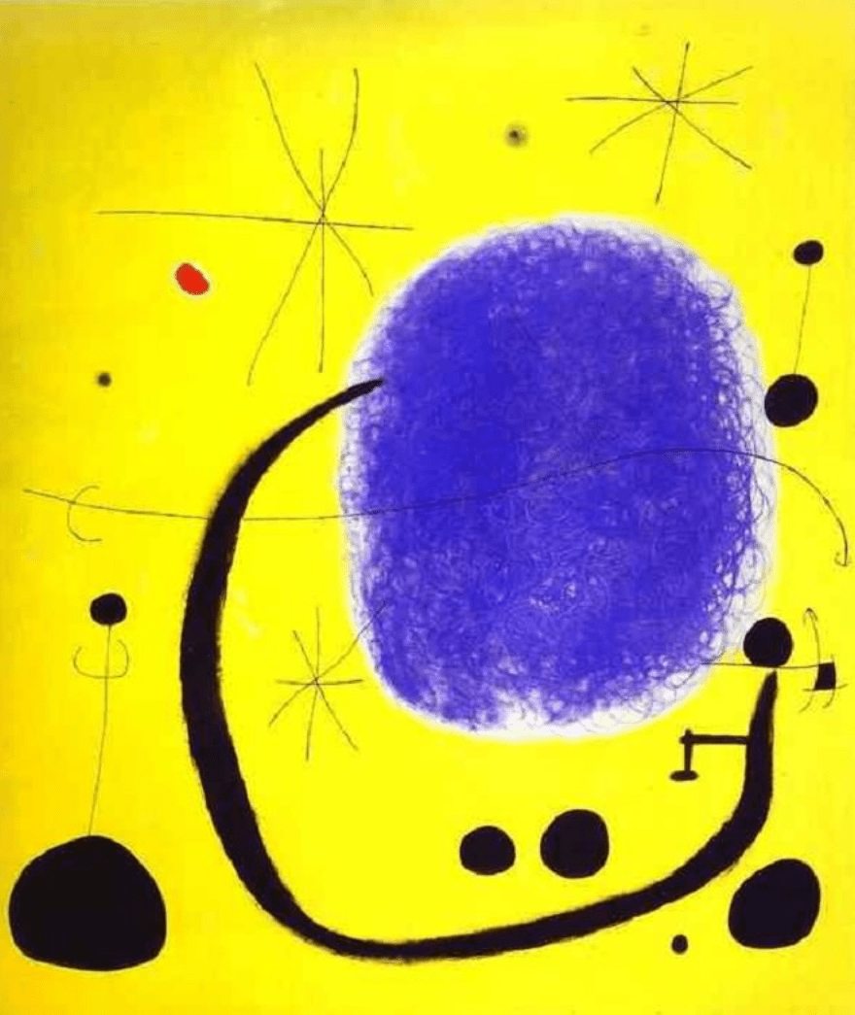 [Miro board – Milestones](https://miro.com/app/board/uXjVKpH0ZYs=/)

 [Miro board – Brainstorming Product](https://miro.com/app/board/uXjVL9qfIn8=/?share_link_id=71274260533)

 [GitHub – TA1-Interoperability](https://github.com/NFDI4Immuno/TA1-Interoperability)

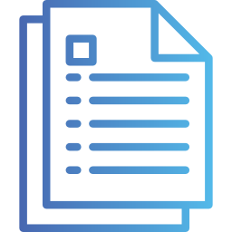 [_OverviewDoc.docx (Minutes overview)](https://nextcloud.nfdi4immuno.de/f/16101)

# Updates (not covered during the call)

* GitLab PM call
  + Added ‘Organisational’ as product
  + Discussed product components and their association
  + Discussed best structure on GitLab to handle connected components – especially metadata model
    - Mariama will research consequences in different structures

# Agenda

* Welcome (5 minutes)
* Update search functionality (Ulrik)
* Open loops for SP25 deadline July 12? (Ulrik)
  + Each group reports
* Is there a need to improve intra-group communication (Ulrik)
* Closing (5 minutes)
* Buffer (5 minutes)

# Action items

|  |  |
| --- | --- |
| **Who** | **What** |
|  |  |